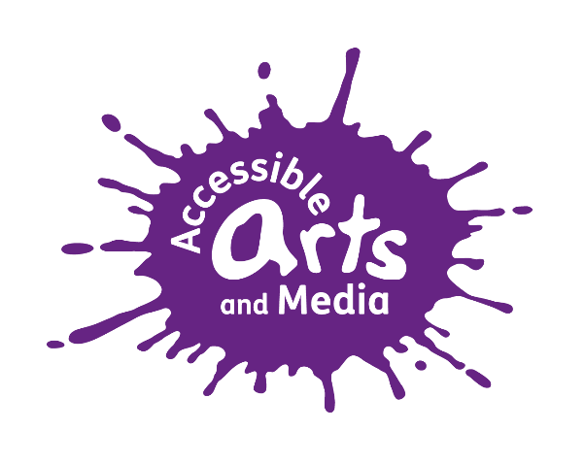

Accessible Arts & Media (AAM) Complaints Policy

March 2020

Designated Person: Rose Kent, Creative Director

Contents

- Overview Page 2
- How to make a complaint Page 2 - 3
- Contact Details Page 3
- Monitoring and reviewing Page 4
5) Appendix 1: Written Complaints Form (to be completed by Complainant) Page 5 – 6
6) For office use only Page 7

Accessible Arts & Media (AAM) Complaints Policy

1) Overview

  - AAM aims to provide its users, organisations and individuals with the best possible service. We positively welcome suggestions you may have for how we can improve our service and our fundraising activities. However, we recognise that from time to time there may be occasions when users of our services or people who come into contact with our fundraising activities feel that the quality or level of service provided fall short of what they could reasonably expect. We do want to know about these occasions so that we can make good the problem and plan to avoid its repetition. In the first instance, AAM would suggest making a verbal complaint either in person or by telephone to the designated person (AAM Creative Director) who will try to resolve the issue informally.

1.2 This policy has been drawn up to:
- provide a fair complaints procedure that is easy to use;
- publicise the existence of our complaints procedure so that people know how to contact us to make a complaint;
- make sure that everyone at AAM knows what to do if a complaint is received;
- make sure all complaints are investigated fairly and in a timely way;
- make sure all complaints are, wherever possible, resolved and that relationships are repaired
- gather information to help AAM improve what we do

  - Complaints may come from service users, their families and carers, staff and volunteers, partners, funders, donors and commissioners and other stakeholders.

1.4 Confidentiality
All complaint information will be handled sensitively, telling only those who need to know and following AAM’s Data Protection requirements.

1.5 Responsibility
Overall responsibility for this policy and its implementation lies with the AAM Board of Trustees.

2) How to make a complaint

2.1 Making an Informal or verbal complaint

2.1.1 In the first instance, AAM would suggest making a verbal complaint either in person or by telephone to the designated person (AAM Creative Director) who will try to resolve the issue informally. If the designated person is not available please refer your complaint to a member of the AAM staff team. If the complaint is about the designated person please refer your complaint the Chair of Trustees. For contact details see section 3.

2.1.2 The designated person shall investigate the complaint and inform the complainant of the result of the investigation, and any corrective action taken – normally within 14 days.

2.1.3 If the complaint is serious, or you are not satisfied after raising it informally with the designated person, you should make a formal complaint.
2.2 Making a formal or written complaint

2.2.1 Your complaint should be made in writing, marked “Private & Confidential", and sent to the designated person or Chair of Trustees. Refer to appendix 1 for a Complaints Form that can be used for this purpose. Remember to keep a copy of your letter or e mail. If you need help in doing this please ask another member of the AAM team.

2.2.2 The designated person shall investigate the complaint and inform the complainant of the result of the investigation, and any corrective action taken – normally within 21 days.

2.2.3 You have the right - if dissatisfied with the results of the inquiry - to put your case in writing or personally to the AAM Trustee Board who will undertake further enquiries and report the decision to the complainant – normally within 30 days and produce recommendations for the Trustee Board if required.

2.3 The Trustee Board will take a final decision on the complaint.

2.4 All complaints and feedback will be fully recorded and a written record will be retained of complaints.

2.5 If you are not satisfied with the Trustee Board’s decision you can request a meeting with a representative from the Trustee Board contact details to refer the issue to the Commissioners of the AAM project or service or alternatively you can contact the Charity Commission if you have a serious concern that you don’t feel has been addressed.

If your complaint is regarding AAM’s fundraising practice and you are not satisfied with the Board’s decision, you can contact the Fundraising Regulator.

3) Contact details

Designated Person  Rose Kent  AAM Creative Director  Sanderson House  Bramham Road, York, YO26 5AR  Email: rose.kent@aamedia.org.uk  Tel: 01904 626965 | Chair of Trustees  Accessible Arts & Media  Sanderson House  Bramham Road, York, YO26 5AR  NB Please do this in writing clearly marking the envelope ‘Private and Confidential’
Fundraising Regulator
2nd floor Email: enquiries@fundraisingregulator.org.uk
CAN Mezzanine Building Tel: 0300 999 3407
49-51 East Road
London,
N1 6AH

4) Monitoring and Reviewing of Complaints Policy.

The policy will be reviewed by the Board of Trustee biennially.

Date approved: 16th March 2020
Next review date: March 2022

Signed by:
Position:
Accessible Arts & Media Complaints Form

To proceed with a complaint, please complete this form and return it to the Creative Director of Accessible Arts & Media. This will enable the complaint to be dealt with appropriately.

Your name:

Your email address:

Your phone number:

Your postal address (if you would prefer us to communicate with you by letter):

Please let us know how you would prefer us to communicate with you:

Email Telephone Post

Please give details of any particular needs we need to bear in mind when we’re dealing with your complaint and communicating with you:

Date and time the incident occurred:

Please give details of your complaint, stating the names of staff or volunteers wherever possible (please continue on a separate sheet if necessary):

If you have already spoken to a member of staff regarding your complaint, please give the name of the staff member:

What do you think should be done to put things right? (Please continue on a separate sheet if necessary)

Please note that in investigating your complaint AAM may be required to provide any named person/s with details of the complaint, to give them a fair opportunity to respond.

Your signature: Date:

AAM Contact details/where to send your complaint:

Designated Person:  Rose Kent  AAM Creative Director  Sanderson House  Bramham Road, York, YO26 5AR  Email: rose.kent@aamedia.org.uk  Tel: 01904 626965 | Chair of Trustees:  Accessible Arts & Media  Sanderson House  Bramham Road,  York, YO26 5AR  NB: Please do this in writing and clearly mark the envelope ‘Private and Confidential’

Date Received:
Date outcome of investigation communicated with complainant:
Outcome of the complaint:
Creative Director/Chair of Trustees signature:
Date:
FOR OFFICE USE ONLY

